Dear colleagues,
We have received the following ERASMUS+ intern vacancy:
Intern professional profile:
Biologist (recent graduate or in the last course of Biology (with interest in Entomology)
No Spanish required
English B2
Internship description:
Non - paid internship
Assistant at the Department of Ethology and Biodiversity Preservation of the EBD-CSIC.
Research project: The Effects of Fire on Ants and other Arthropods
Project summary:
With this PhD project we want to analyze the consequences of fire on three groups of epigeal and aerial arthropods (ants, spiders and bees) often used as bioindicators for ecosystem recovery. The aim of the thesis is to understand how species, communities and ecosystems respond to environmental changes caused by fire.
We will do so by studying its effects on:
1) Patterns of abundance, richness and biodiversity of ants, spiders and bees
2) Functional diversity of ants, spiders and bees
3) Dominance relationships in the communities of ants
4) Use of trophic resources by ants
5) Temperature resistance in ants
We need a volunteer to help with some goals. After the collaboration, the intern will receive a certificate of participation in the project.
Main tasks of the intern:
- Distinction and classification of the extracted material from the field
- Classification of ants
- Field work in burned areas of Andalusia

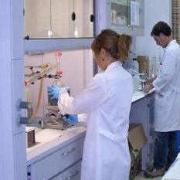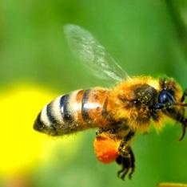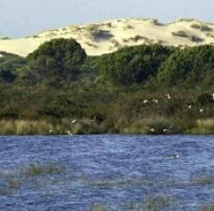

Are you an ERASMUS+ student or recent graduate willing to
apply for this internship position?

CONTACT US
Frieda González/Incoming coordinator
Email: info@oneco.org
Phone: +34 954224036
Skype: onecofrieda
URL: www.oneco.org

